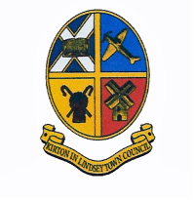

Minutes of the Extraordinary Meeting of Kirton in Lindsey Town Council held on Wednesday 29nd
March 2017 at the Town Hall, High Street, Kirton in Lindsey at 7.30pm.

Prior to the meeting, Prayers will be led by Cllr Pat Frankish

Public Participation:
Members of the public may raise subjects, which they wish to bring to the attention of the Town Council. The time will be restricted to 15 minutes maximum unless the Council decides otherwise. Members of the public should note that decisions cannot be made at this meeting on items not on the agenda.

MINUTES

1703/01 Apologies for Absence
Apologies for Absence were received from Cllr Kathy Cooper, Cllr Andrew Kofoed, Cllr Joy Kofoed and Sam Layzell.

1703/02 Declaration of Interests / Dispensations
a. No Declarations of Interests were made.
b. No Dispensations were sought/granted

1703/03 To consider the following Consultations:
(i) The Council considered the North Lincs. Local Plan (2017 – 2036) Initial Consultation a filled out the relevant questions
RESOLUTION: That the Questionnaire was completed and will be directed to North Lincolnshire Council. ACTION: Town Clerk

